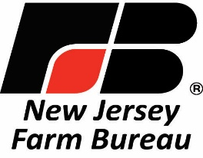

Phone: 609-393-7163

Fax: 609-393-7072 Email: [mail@njfb.org](mailto:mail@njfb.org)

Website: [www.njfb.org](http://www.njfb.org)

168 West State Street Trenton New Jersey 08608

Because Agriculture Matters!

June 10, 2025

To: Honorable Craig Coughlin, Speaker

New Jersey General Assembly

From: Allen Carter, president

Re: FY’24 appropriations – A4569

State Agriculture Development Committee

We are aware that the remaining details of negotiated issues with the governor’s office is at or very near completion. That is exciting news for the farmland preservation program and the entire production agriculture industry. It is hoped that the bill is ready for posting and final approval at the next voting session of the Assembly later this month.

We wholeheartedly endorse the continued financial support of the program and its many facets. Since its beginnings in the early 1980’s, the SADC and its constituent county agriculture development boards have built an enviable record of purchasing conservation easements on more than 252,000 acres of active, productive farmland. It has done so in a complementary fashion with other open space and environmental protection programs to meet the expectations of the state’s nine million residents. In our case, it helps to ensure a large permanent land base for locally grown food as we face a future with numerous risks.

Our outlook for economic sustainability is immeasurably assisted by the knowledge of having the support of state policy-makers at our back. Full funding of the state preservation program is a strong demonstration of that support. We feel confident that the experience and institutional structure of the program is sound and responsive to meet whatever challenges it encounters. We know by your support for linking local produce purchase with hunger abatement and for the training/education role by Rutgers University for farmers that you appreciate what agriculture brings to the state.

We look forward to the enactment of this bill and the major contributions it will provide to our farming industry and to the general well-being of our great state.

Thank you for your consideration.

#

Cc: Members of the General Assembly

Office of the Governor

Ed Wengryn, Secretary of Agriculture and SADC chairman